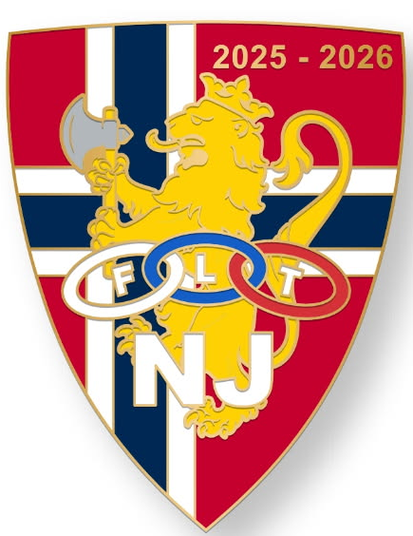

Testimonial Dinner for
Geirr Stende
Grand Master of New Jersey
1:00pm – 4:00pm
Saturday, April 18, 2026

Grand Lodge Hall
112 - 4th Ave
Roebling NJ 08554

