
Grand Lodge Session Invitation 2026
Attn: all Members of All Units of the Independent Order of Odd Fellows,
The Jurisdiction of New Jersey Grand Master Geirr Stende and Grand Patriarch Victoria Burger and President of the Rebekah Assembly Benjamin Burger, invite you to attend the 193rd Session of the Grand Lodge and the 182nd^{t} Session of the Grand Encampment, 137th Session of the Rebekahs Assembly which will be held June 23 2026 through June 25th 2026, at the Claridge Hotel , 123 South Indianna Ave, Atlantic City, NJ 08401 on June 24th, 25th and 26st of 2026. Please join us.

Hotel Accommodations

Rooms have been secured at very favorable rates. Reservations should be made directly with the hotel by calling +1 (844) 507-0955. Rates: $72.00 night + taxes. Keep self-parking receipts for a partial reimbursement after the session. Email receipts to Ben Burger BB.burger1970@gmail.com. Please be sure to state that you are with the Odd Fellows and use this code ODDF0626 or scan the QR code to the right to qualify for the very reasonable rates. The deadline for room reservations is June 4, 2026
https://reservations.travelclick.com/114524?groupID=4981680
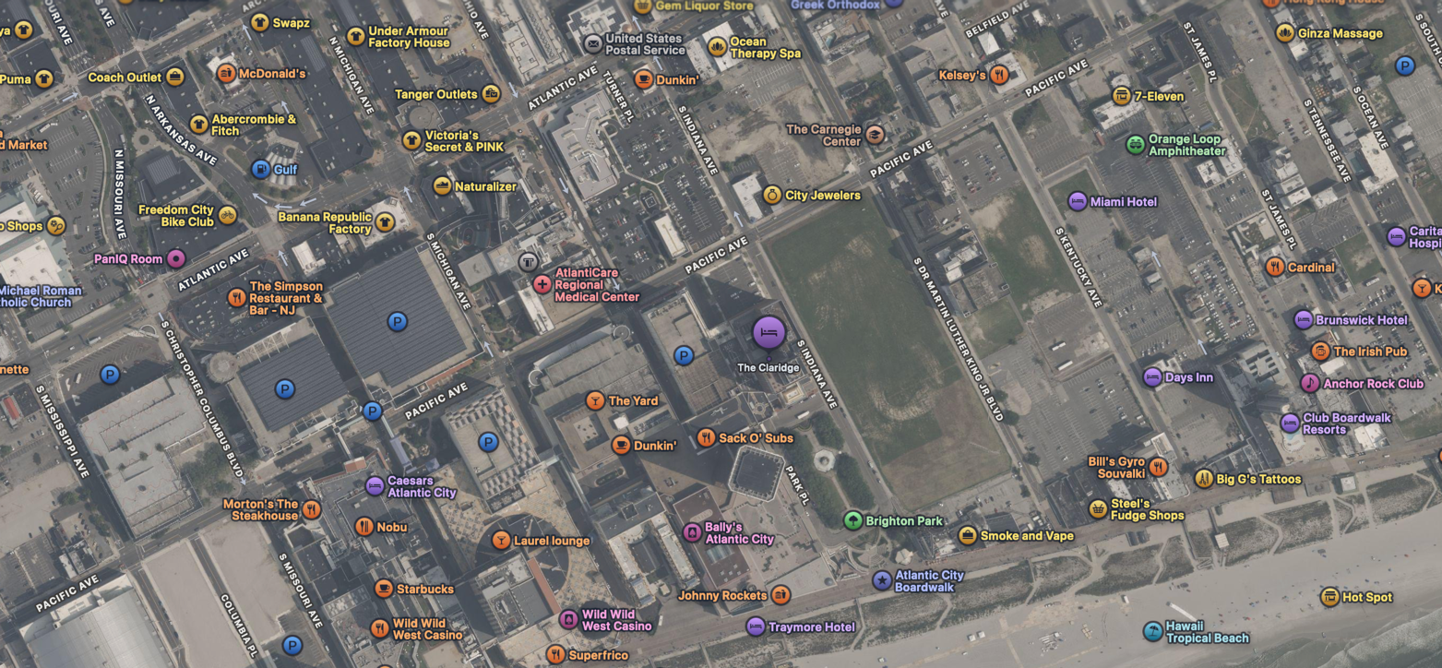

Sessions
The Rebekah Assembly will Convene in the second floor Conference Center, at 9:00 Tuesday morning, The Grand Encampment Session will convene in the second floor Conference Center, on Wednesday at 1:00p.m. Wednesday night between 7:00-11:00PM is Entertainment Night, come and enjoy an evening with friends in the VU Bar Located on the 23th floor, with beverages, snacks, for more information contact Ben Burger on his cell 856-313-4870.
The Grand Lodge Session will be held on Thursday, June 25 at 9:00 a.m. in the second floor conference center. There will be a public memorial service for Encampment and Lodge members at 11:15 a.m. Following the Memorial Service, a buffet lunch of sandwiches and wraps will be available; held in Ocean City Room on the second floor, The Grand Lodge session will reconvene at 1:00p.m.
On Thursday evening the Grand Lodge / Grand Encampment/Rebekah Assembly will host the combined banquet. Held in the Main Ballroom, there will be a Social Hour, with a cash bar, from 5:00 – 6:00 pm, followed immediately by the banquet. After dinner, the Installation of Grand Lodge Officers will take place, to be followed by a reception in the Main Ballroom. All are welcome to join us in wishing the best to our new leaders. A buffet breakfast will be available on Thursday and Friday mornings Ocean City Room.

Please complete the enclosed reservations sheet and return it to Carla Simmons, 109 26th Ave. Monroeville, NJ 08343. All reservations, rooms and meals must be made by June 1, 2026, we hope you will make it and we look forward to seeing you at our sessions. Questions can be directed to Gr Secretary Debbe McClelland at oddfellows22@comcast.net or 609-519-8504.
NOTE: All reservations or Changes After 6/01/2026 are subject to a $15.00 Late Fee, per person. Please make checks payable to: Grand Lodge of NJ.
Please Note: Dress Code is Business Attire – Mandatory to Attend Meetings
Men: Jacket and Tie – Women Dress or Pant Suit
Not Acceptable: Jeans, Jean Jackets, T-shirts, Sneakers, Sandals, Flip Flops Shorts or Beach Attire.

Fraternally yours,
Geirr Stende Victoria Burger Benjamin Burger
Grand Master Grand Patriarch Rebekah Assembly President

Registration Form
(Due by June 1, 2026, or Late Fee Applies)
BREAKFAST RESERVATION FORM
Claridge Deluxe Breakfast buffet is offered Thursday and or Friday morning for $26 per person per meal, children 13 and under eat free.
Name: | Lodge # | Thursday | Friday | Total

LUNCH RESERVATION FORM
A lunch buffet is offered Thursday for $30 per person per meal, children 13 and under eat free.
Name: | Lodge # | Thursday | Total

DINNER RESERVATION FORM
Please join us for the banquet dinner Thursday evening Pricing varies depending on meal choice please indicate your preference of Herb Crusted Salmon or Chicken Piccata $40, NY Strip Steak $50
Name: | Lodge # | Salmon $40 | Chicken $40 | Steak $50
** If you would like to be seated with someone at the table, please list their names:

____________________________________________________________________________________________
Contact Name:___________________ Phone Number: ________________
Email: ___________________________________________________________
Total of meals above: ____________ Late Fees if applicable ($15 Per person) _____________
Total Amount enclosed: _____________

