Testimonial Weekend

for the

Honorable  
Thomas J. Calabrese

Sovereign Grand Master

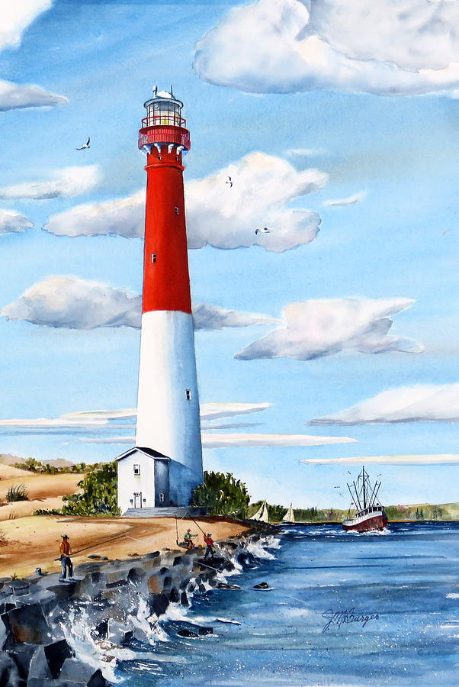

October 30th – November 1st 2025

Claridge Hotel

Atlantic City, NJ



Dear Brothers and Sisters, -

It is with great honor and heartfelt enthusiasm that we invite you to join us for a momentous occasion — the Testimonial Weekend celebrating The Honorable Thomas J. Calabrese, Sovereign Grand Master. This special tribute will be held from Thursday, October 30th through Saturday, November 1st, 2025, at The Claridge Hotel located at 123 S Indiana Avenue, Atlantic City, NJ 08401.

We have secured a special group rate at The Claridge Hotel for your convenience: Thursday, October 30: $56. Friday, October 31: $126. Saturday, November 1: $196. *All rates are subject to applicable taxes.* To reserve your room, please visit:<https://reservations.travelclick.com/114524?groupID=4566090>. Alternatively, you can book through www.Claridge.com using the attendee code: SOV2024. We encourage you to make your reservations promptly to ensure availability at these special rates.

If traveling by air. Spirit and American Airlines service Atlantic City airport (ACY). If traveling by car, there is parking at the hotel. Which we are still negotiating the price for hotel guests.

Weekend Program Schedule

Thursday, October 30, 2025

We will commence the festivities with an informal gathering atop the Claridge at the VUE Rooftop Lounge, offering a splendid View of the Jersey Shore, Sub/Hoagie sandwiches and drinks. Join us for an evening of fellowship from 5:30 p.m. to 8:00 p.m. Casual attire is recommended for this relaxed event. The admission fee is $20 per person, and open seating will be available.

Friday, October 31, 2025

Experience the rich history of New Jersey with an engaging bus tour featuring the iconic USS New Jersey Battleship and other significant Jersey sites. Departure is scheduled for 9:30 a.m., returning at approximately 5:00 p.m. Lunch on the Battleship is included. The cost for this full-day excursion is $50 per participant. This is a wonderful opportunity to enjoy meaningful sights with your Brothers and Sisters.

Saturday, November 1, 2025

The highlight of the weekend will be the Testimonial Banquet honoring The Honorable Thomas J. Calabrese. The evening begins with a Social Hour at 5:30 p.m., followed by Dinner and Entertainment at 6:30 p.m. Formal attire is requested to mark this distinguished occasion. Tickets are $60 per person.

In conjunction with the weekend’s events, we are preparing a commemorative Ad Book. We invite you, your lodge, or any affiliated organizations to place congratulatory messages or advertisements. Please refer to the attached forms for detailed information on rates, submission guidelines, and deadlines. Your support via the Ad Book is greatly appreciated and adds a lasting tribute to our Sovereign Grand Master.

Please review the enclosed forms for complete details on event registration and Ad Book submissions. Kindly submit your reservations and payments by the deadline indicated on the forms to ensure your place at this special gathering. Should you require further information or assistance, please do not hesitate to contact committee chairman Raul Rodriguez at raulioof@aol.com or 646 209-7328 Adis Roman 201-925-2584

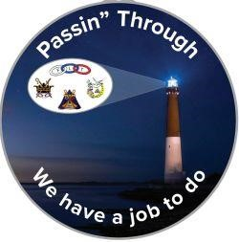

Testimonial Weekend Honoring

The Honorable Thomas J. Calabrese

Sovereign Grand Master

October 30 – November 1, 2025

Location: The Claridge Hotel

123 S Indiana Ave, Atlantic City, NJ 08401

Rate: Thursday $56, Friday $126, Saturday $196 per night plus applicable taxes. Room reservations should made using <https://reservations.travelclick.com/114524?groupID=4566090> or Claridge.com use attendee code: SOV2024

Registration = One Form Per Person – Deadline October 7th, 2025 not responsible after Deadline

Name_____________________________ Phone__________________________Title/Rank__________________________

Email____________________________________________ Jurisdiction ___________________________________________

Travel Information ______________ Flight information_________________________________________________________

Attending: (Please select)

Thursday- October 30 – View of Jersey Shore – Casual Attire $20

5:30 pm to 8:00 pm – Open seating at the VUE roof top of the Claridge

Friday – October 31 – USS New Jersey Battleship & Jersey sites Bus Tour $50

9:30 am to 5:00 (Fill out and return the attached Bus Tour form)

Saturday – November 1 – Testimonial Banquet – Formal Attire $60

5:30 pm Social Hour, 6:30 pm Dinner & Entertainment

Please Select Entrée Choice

Chicken Piccata

Honey Mango Glazed Salmon

Chianti Braised Short Ribs

Special Need or A Meal ___________________________________ Total ___________

Make Check out to: Grand Lodge of NJ IOOF

Mail to: Ben Burger

265 Evergreen Dr

Willingboro, NJ 08046



*Bus tour of Jersey*

*10/31/25 9:00am -5:00pm*

Stop #1

Pick a Battle Tour Choice:

Fire Power Tour: Our knowledgeable tour guides will take your group through the Battleship’s awesome 16″ Gun Turrets and other weapons systems, the Admiral’s and Captain’s Cabins, Combat Engagement Center, Navigational Bridge, Wardroom, Forward Berthing, and much more! On your tour, you will learn about the critical role the Battleship New Jersey played in World War II, Korea, Vietnam, and the Middle East, as well as understand why she was the most feared ship ever to stalk the seas.

Main Deck Tour: This tour is ADA- accessible! Guests can use the pier elevators to get up and down to the Battleship's main deck, which features the 16-Inch Guns, Officer’s Wardroom, Helicopter, and more. It does not provide access deeper into the ship.

Pick a lunch choice:

: *please note that all adult lunches include pasta salad, chips, dessert and a bottle of water*

|  |  |
| --- | --- |
| Ham and Cheese w/Honey Mustard on Rye |  |
| Roast Beef w/Horseradish on Kaiser Roll |  |
| Turkey w/ Mustard Mayo on Multigrain Bread |  |
| Chicken Salad on Croissant |  |
| Tuna Salad on Croissant |  |
| Grilled Vegetables with Hummus Wrap |  |

Stop #2



Souvenir Program Booklet

The Honorable Thomas J. Calabrese

Sovereign Grand Master

Deadline October 7, 2025, no exception

Souvenir Program Booklet Advertisement Order Form

*All printing is in Black & White*

|  |  |  |  |  |  |
| --- | --- | --- | --- | --- | --- |
| |  | | --- | | Full Page  5 ½ Wide X  8 ½ Tall Price:  $60 | | |  | | --- | | Half Page  5 ½ Wide X  4 ¼ Tall  Price: $40 | | |  | | --- | | Quarter Page  (Vertical)    2 ¾ Wide  X  4 ¼ Tall    Price $25 | |
| |  | | --- | | Quarter Page  (Horizontal)  5 ½ Wide X 2 ⅛ Tall | |

Booster, one line, individual or couples: Price $5

*One form per Advertisement*

Name: __________________________________ Amount Included: _______________

Type of Ad: □ Full Page □ Half Page □ Quarter Vert. □ Quarter Horz. □ Booster

If Booster, line of text: ____________________________________________________

Make checks payable to: GRAND LODGE of NJ IOOF

Send form & checks to Ben Burger, 265 Evergreen Dr Willingboro, NJ 08046

Please send copy to Raul Rodriguez to: [raulioof@aol.com](mailto:raulioof@aol.com)